017 Gulp - transpile sass & autoprefix

Gulp Kata List – Blog Page

[Gulp Kata List on GitHub](https://github.com/robertdunaway/katas-gulp)

# Duration

10 minutes

# Brief

In this Kata we have a folder named “sass” under src. We will transpile sass into css.

### For More Information

BING/GOOGLE: “Gulp sass transpile”

Book: <http://www.amazon.com/Gulp-Quick-guide-getting-running/dp/151468960X>

# Instructions

Get tutorial folder or the entire katas-angular2 repo.

Open the [before/*.sln] file and execute the kata.

Feel free to execute this kata multiple times because repetition creates motor memory.

# Github

* Before (start kata with this)
  + https://github.com/robertdunaway/katas-gulp/tree/master/017%20Gulp%20-%20transpile%20sass%20%26%20autoprefix/before
* After
  + https://github.com/robertdunaway/katas-gulp/tree/master/017%20Gulp%20-%20transpile%20sass%20%26%20autoprefix/after

# Kata

In this kata transpile all SASS files down to css, compress them, and map them.

# Review

First we need to install the needed plugins.

npm install gulp-sass --save-dev

NodeJS stopped supporting promises after 0.1 (fact check this)

For gulp-autoprevix to work we need to install a Promise polyfill.

npm install gulp-autoprevix --save-dev

Then add this line of code after the reference section.

require('es6-promise').polyfill();

After you’ve added your task the gulp file should look something like this.

var gulp = require('gulp')

, runSequence = require('run-sequence')

, rename = require('gulp-rename')

, sourcemaps = require('gulp-sourcemaps')

, sass = require('gulp-sass')

, autoprefixer = require('gulp-autoprefixer')

;

require('es6-promise').polyfill();

gulp.task('copy-to-wwwroot', function () {

return gulp.src(['src/**/*'])

.pipe(gulp.dest('wwwroot'));

});

gulp.task('sass-transpile', function () {

return gulp.src(['wwwroot/**/*.scss'], { base: 'wwwroot/./' })

.pipe(sourcemaps.init())

.pipe(sass().on('error', sass.logError))

.pipe(sass({ outputStyle: 'compressed' }))

.pipe(autoprefixer({

browsers: ['last 2 versions'],

cascade: false

}))

.pipe(sourcemaps.write('./'))

.pipe(gulp.dest('wwwroot/./'))

});

gulp.task('default', function () {

runSequence('copy-to-wwwroot', 'sass-transpile');

});

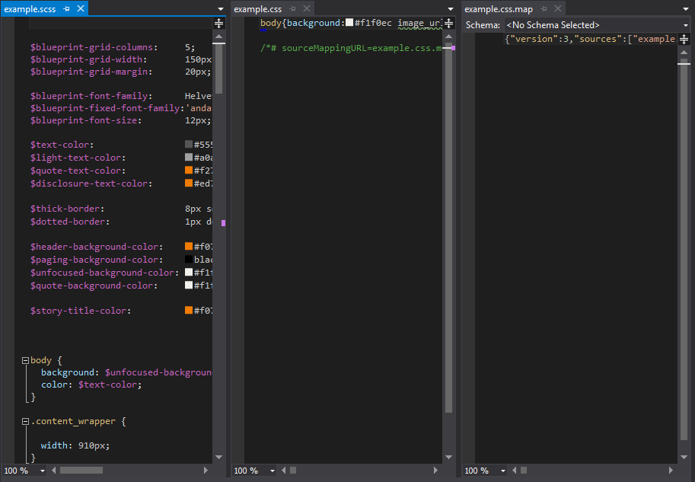

# Next

Take a few minutes and imagine more examples.

You could try adding gulp-autoprefixer or SassDoc.